**COMPUTER NETWORKING LAB (NCS-651)**

**1**. COMMAND => hostname

OUTPUT:

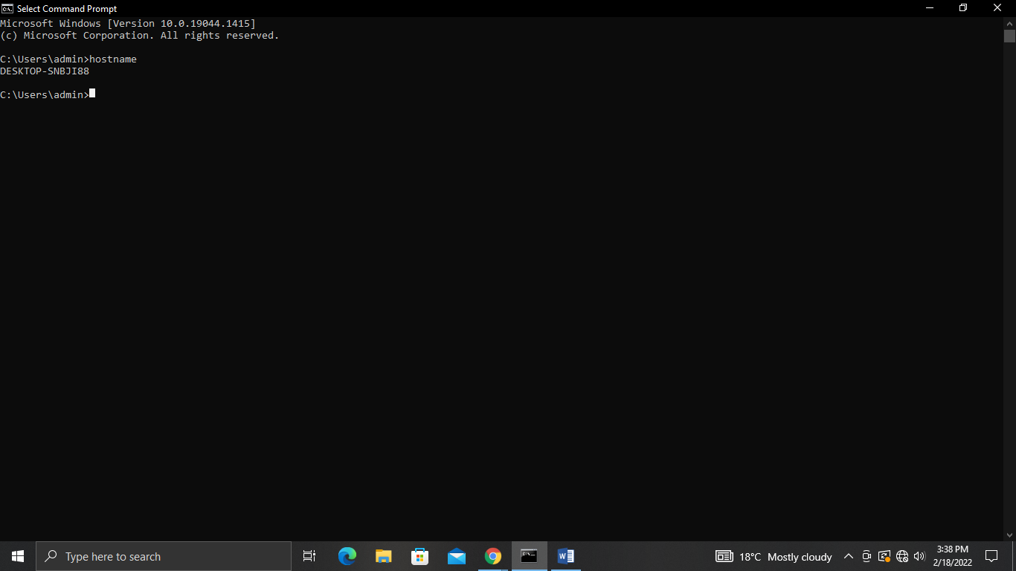

**2**. COMMAND => ipconfig

OUTPUT:

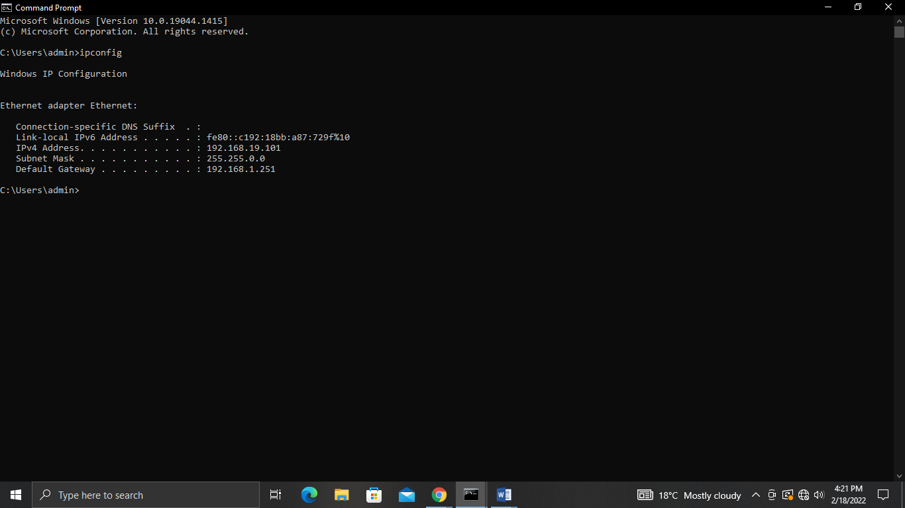

**3**. COMMAND => ipconfig/all

OUTPUT:

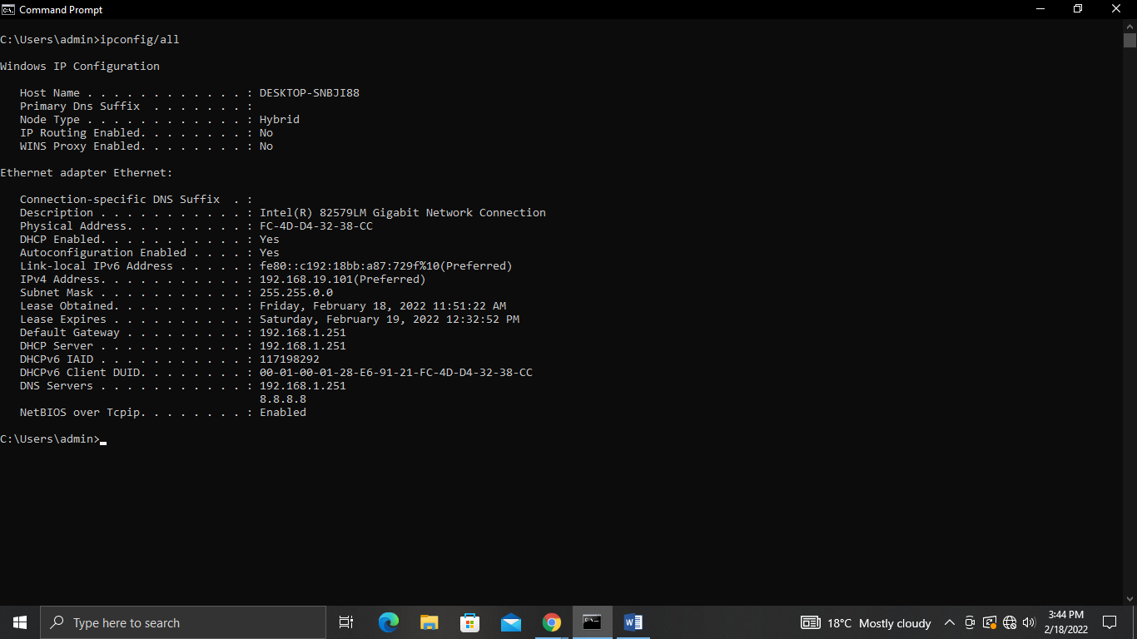

**4**. COMMAND =>nslookup

OUTPUT:

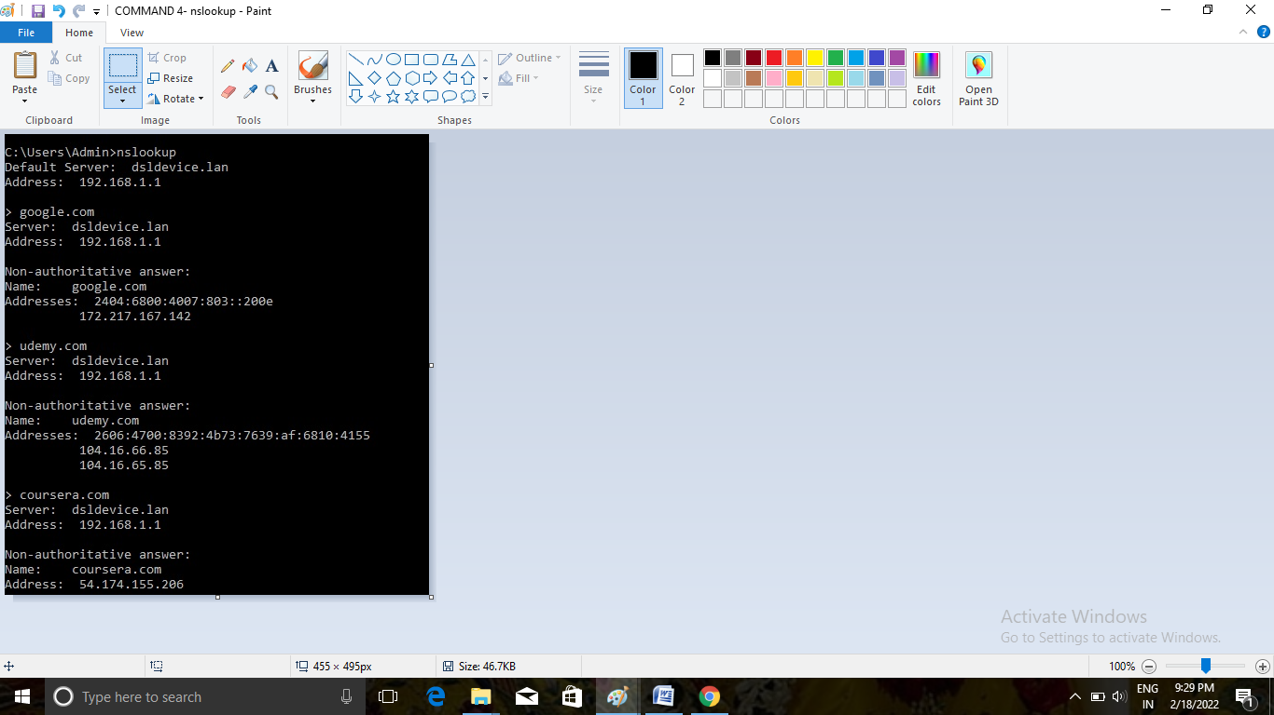

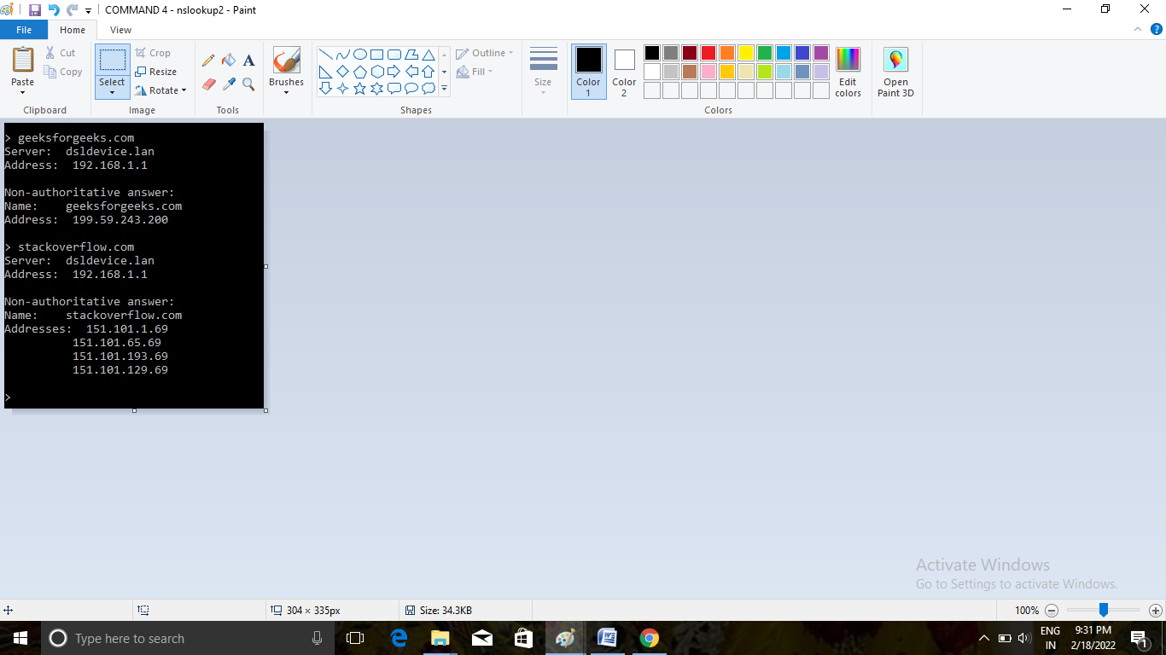

**5**. COMMAND =>systeminfo

OUTPUT:

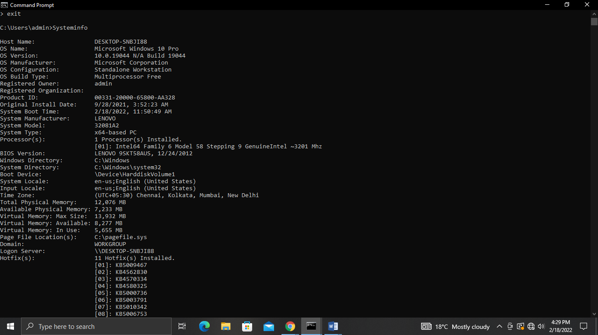

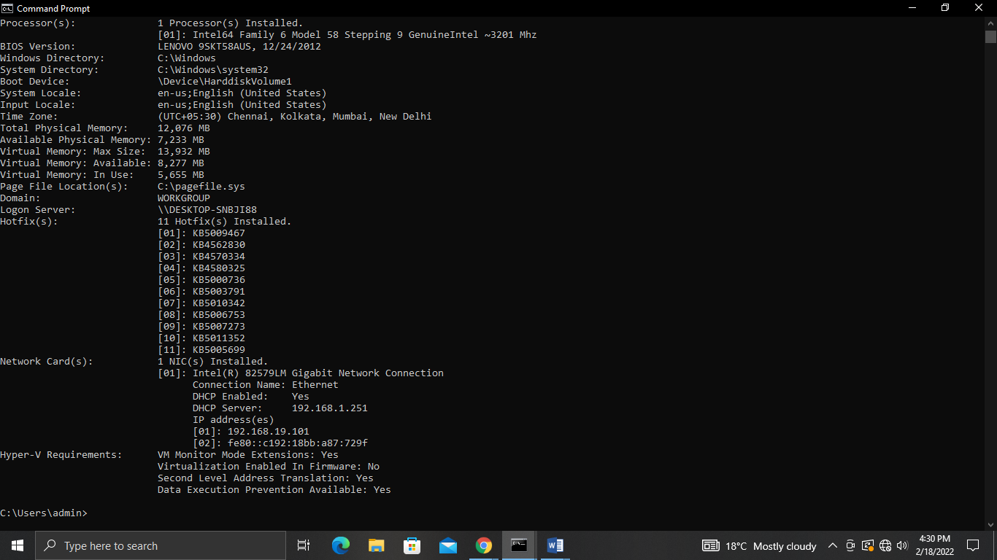

**6**. COMMAND =>netstat

OUTPUT:

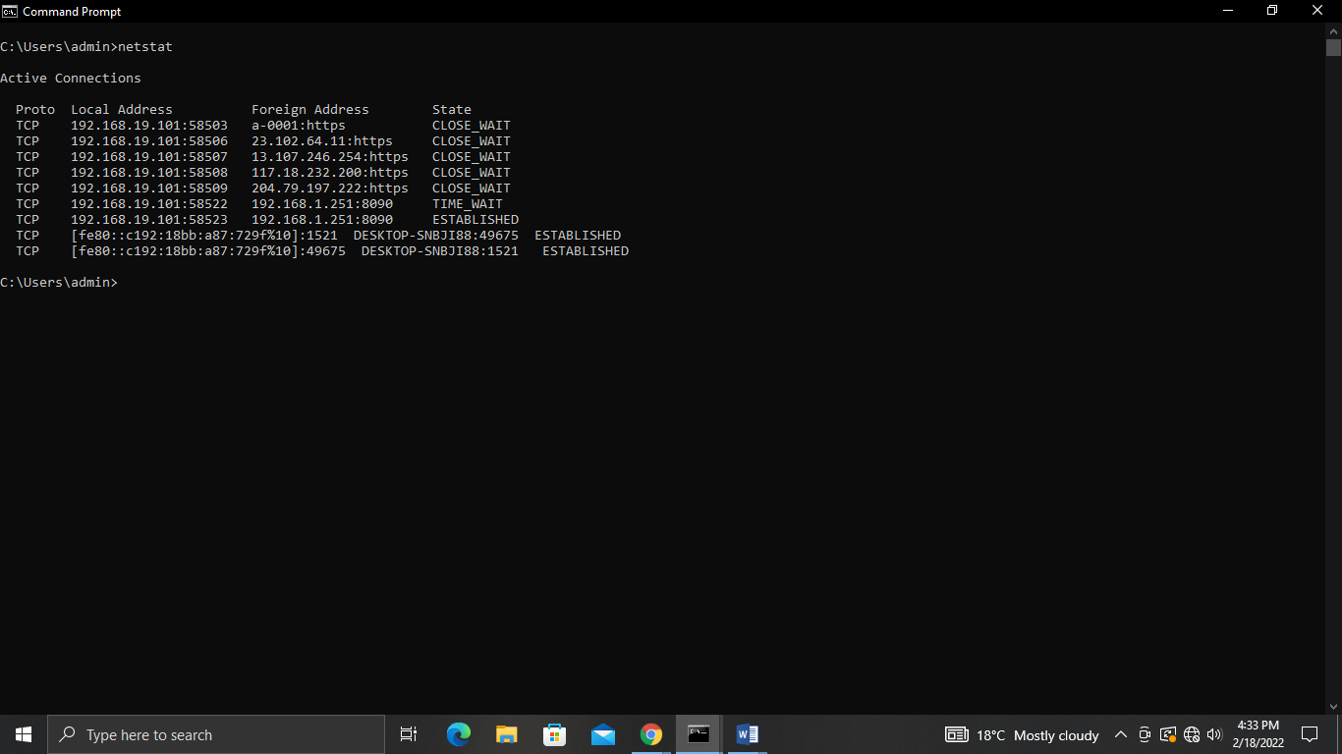

**7**. COMMAND =>ping

OUTPUT:

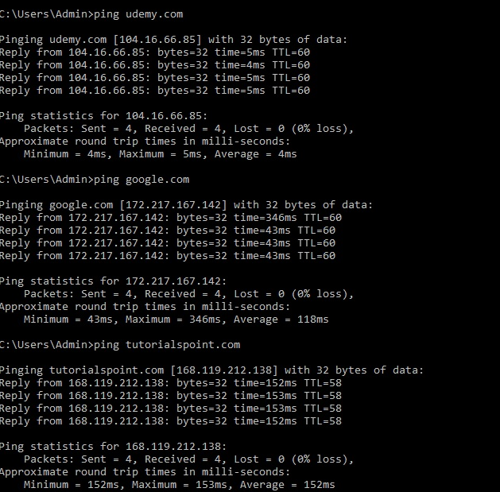

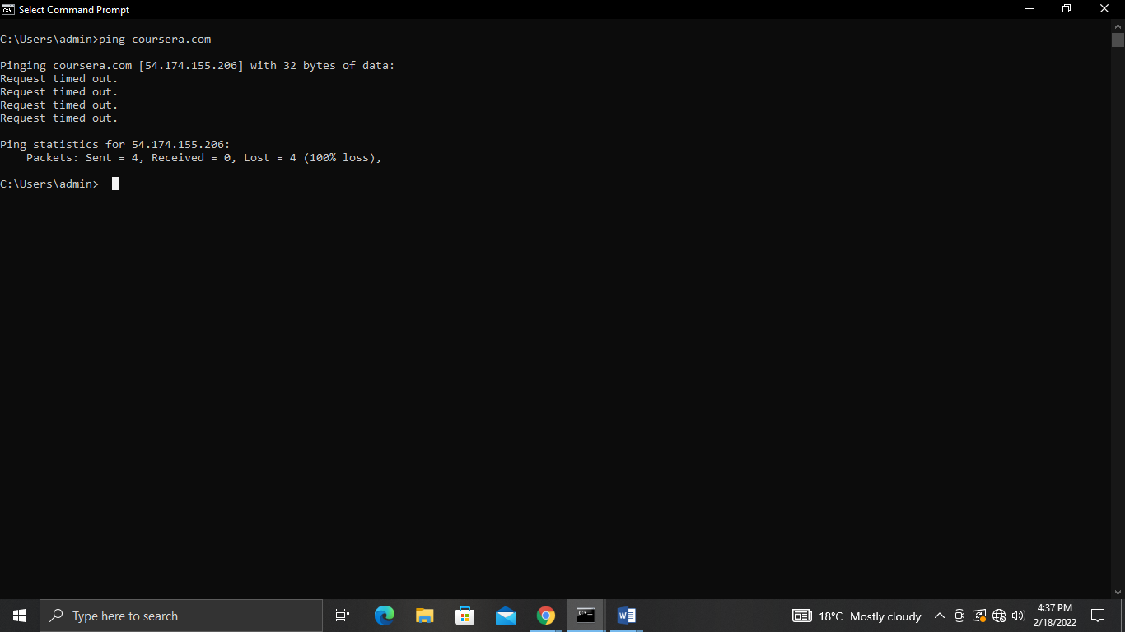

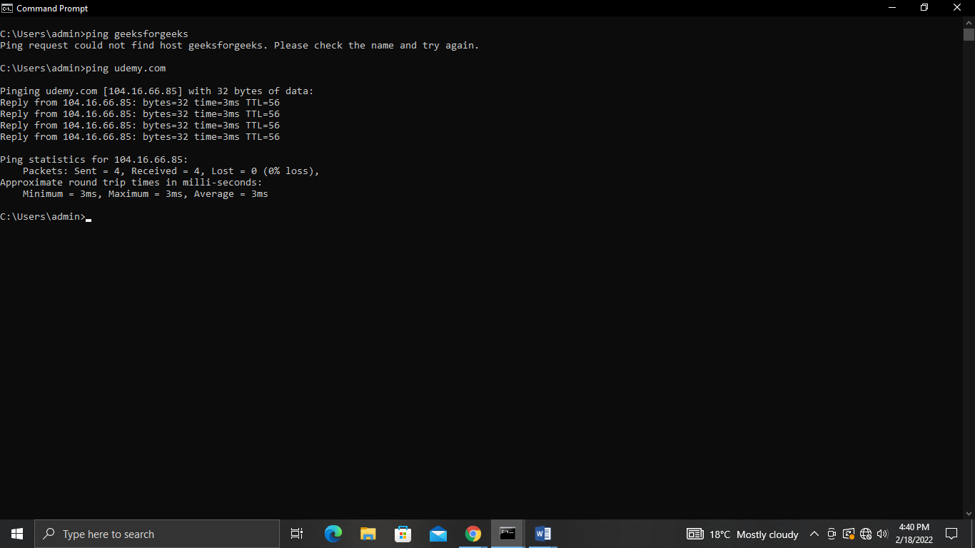

**8**. COMMAND =>tracert

OUTPUT:

